SQL Case Study 3: Texture Tales

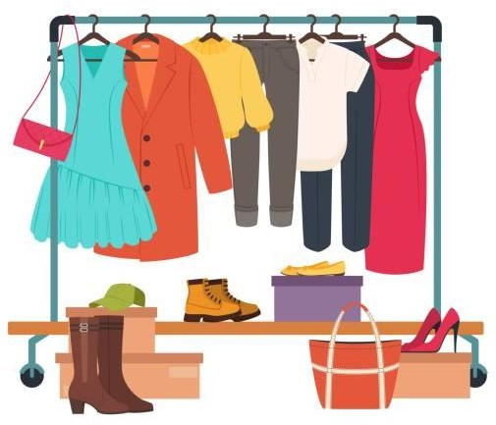

INTRODUCTION

Texture Tales Clothing Company prides themselves on providing an optimized range of clothing and lifestyle wear for the modern adventurer!

I, the CEO of this trendy fashion company is asking you to assist the team’s merchandising teams analyze their sales performance and generate a basic financial report to share with the wider business.

**Done By : L. ANUSH BHARATHWAJ**

**[LINK](https://drive.google.com/drive/folders/1Hb1DTIuGE0gabzZOaDQelRYtDS2lZBSD?usp=sharing)**

SCHEMA USED

**sales**

|  |  |
| --- | --- |
| **product_details** | |
| product_id | varchar |
| price | int |
| product_name | varchar |
| category_id | int |
| segment_id | int |
| style_id | int |
| category_name | varchar |
| segment_name | varchar |
| style_name | varchar |

prod_id varchar

qty int

price int

discount int

member varchar

txn_id varchar start_txn_time varchar

# product_prices

id int

# Product_hierarchy

id int

product_id int

price int

product_id varchar

price int

start_date date

end_date date

CASE STUDY QUESTIONS

1. **What was the total quantity sold for all products?**

**select details.product_name as product , sum(qty) as qty**

**from product_details as details inner join sales**

**on details.product_id = sales.prod_id**

**group by product order by qty desc;**

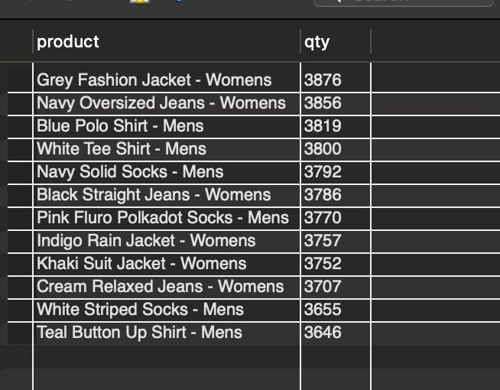

1. **What is the total generated revenue for all products before discounts?**

**select concat('$',sum(qty * price)) as Total from sales ;**

1. **What was the total discount amount for all products?**

**select concat(sum(price*qty*discount)/100,'%') as Total from sales;**

1. **How many unique transactions were there?**

**select count(distinct txn_id) from sales;**

1. **What are the average unique products purchased in each transaction?**

**with cte_trans as**

**(**

**select t.txn_id , count(distinct p.product_name) as**

**counts**

**from sales t inner join product_details p**

**on p.product_id = t.prod_id**

**group by t.txn_id**

**)**

**select round(avg(counts)) as avg_prod from cte_trans;**

1. **What is the average discount value per transaction?**

**with cte_discount as**

**(**

**select txn_id, sum(discount * qty * price)/100 as discount from sales group by txn_id**

**)**

**select round(avg(discount)) as avg_discount from cte_discount;**

1. **What is the average revenue for member transactions and non- member transactions?**

**with cte_revenue as**

**(**

**select member ,txn_id, sum(qty*price) as revenue from sales group by member,txn_id**

**)**

**select member, round(avg(revenue)) as avg_revenue from cte_revenue group by member;**

1. **What are the top 3 products by total revenue before discount?**

**select p.product_name,sum(s.qty*s.price) as revenue from**

**product_details p inner join sales s**

**on p.product_id = s.prod_id**

**group by p.product_name**

**order by revenue desc**

**limit 3;**

1. **What are the total quantity, revenue and discount for each segment?**

**select p.segment_id,p.segment_name, sum(s.qty*s.price) as revenue , sum(s.qty*s.price*s.discount)/100 as discount**

**from sales s inner join product_details p**

**on p.product_id = s.prod_id**

**group by p.segment_name, p.segment_id;**

1. **What is the top selling product for each segment?**

**select p.product_id,p.style_id,p.segment_name,p.product_name , sum(s.qty) as qty**

**from product_details p inner join sales s**

**on p.product_id=s.prod_id**

**group by p.segment_name,p.product_name, p.product_id,p.style_id;**

1. **What are the total quantity, revenue and discount for each category?**

**select p.category_name,sum(s.qty) as qty , sum(s.qty*s.price) as revenue , sum(s.qty*s.price*s.discount)/100 as discount**

**from product_details p inner join sales s**

**on p.product_id = s.prod_id**

**

1. **What is the top selling product for each category?**

**select p.category_name,p.product_name,sum(s.qty) as qty**

**from sales s inner join product_details p**

**on p.product_id=s.prod_id**

**group by p.category_name,p.product_name**

**order by qty desc**

**